3 Aug 2019

**Compiling Program for Standalone Application**

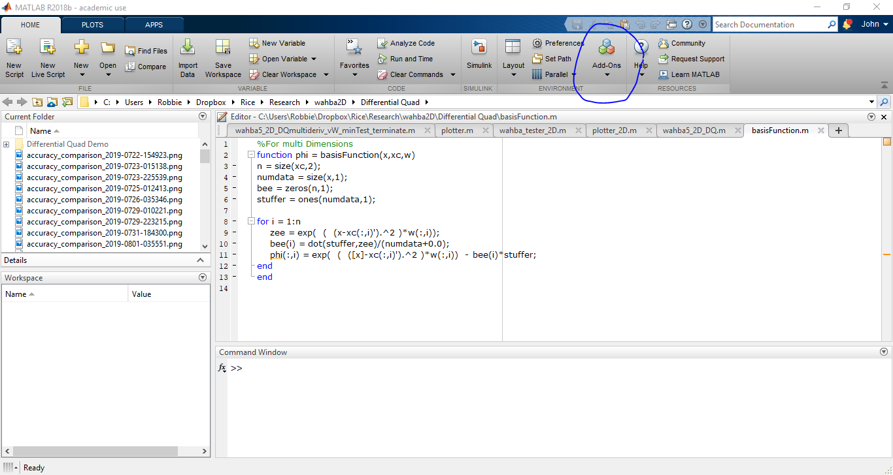

From Matlab, got to Home>Add-Ons>Get Add-Ons

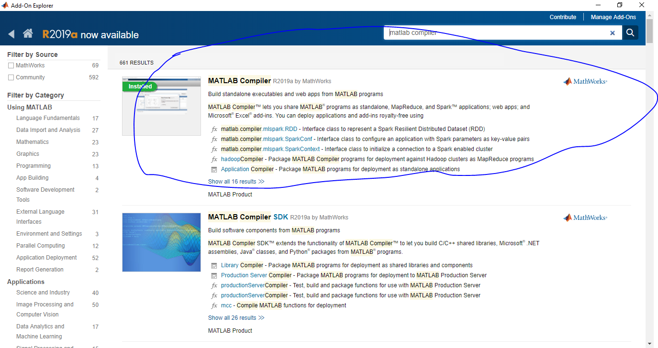

Search for and install the ‘MATLAB Compiler’

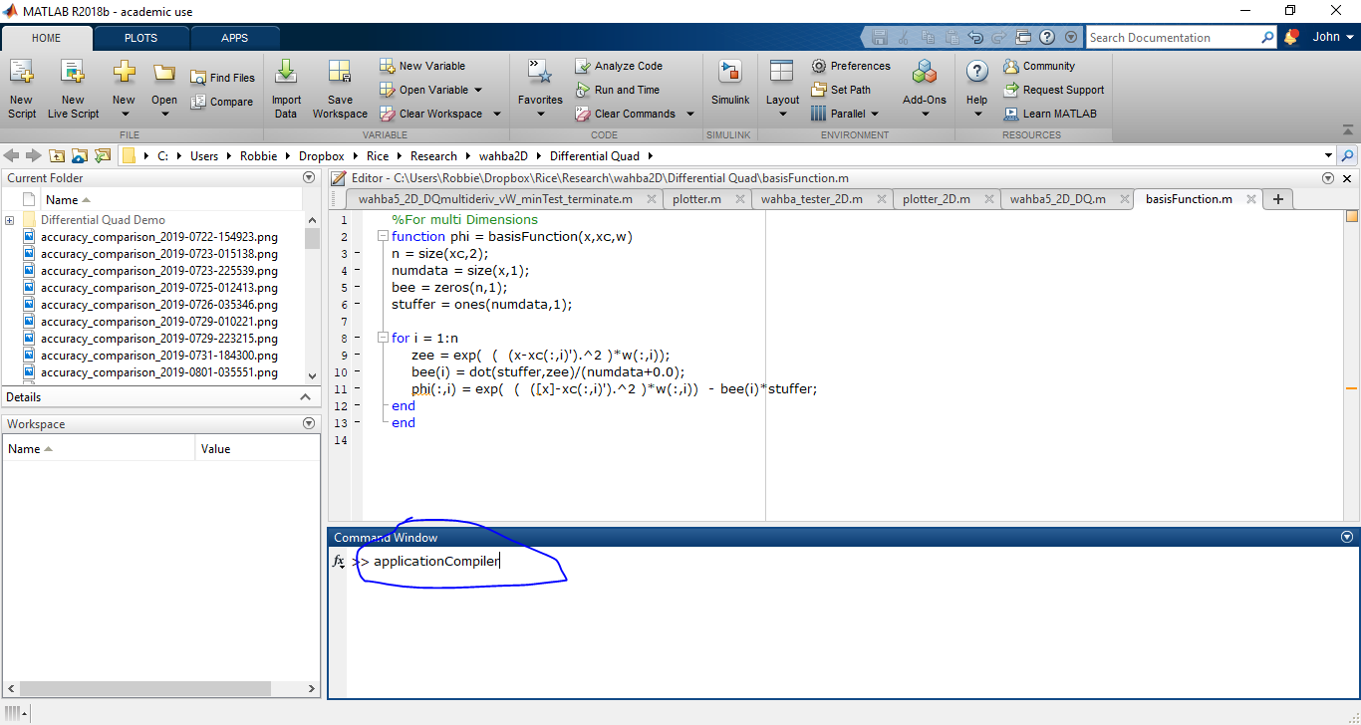

Once installed, launch the compiler by entering the command ‘applicationCompiler’ in the command window

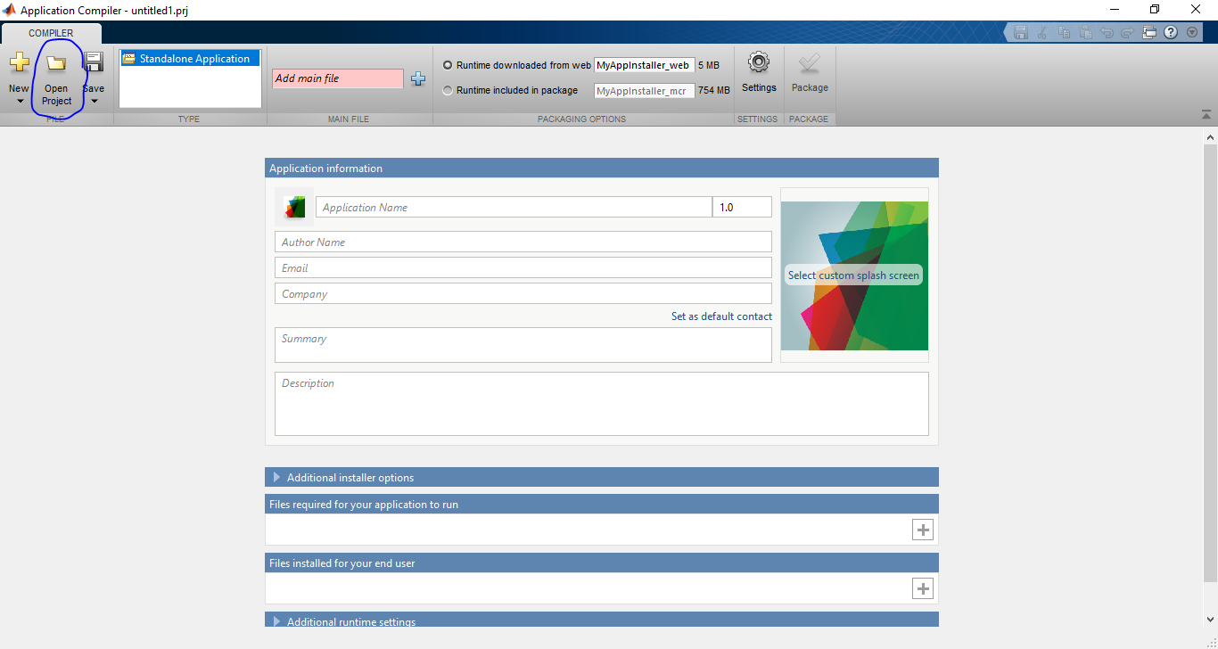

Select ‘Open Project’ in the Compiler window

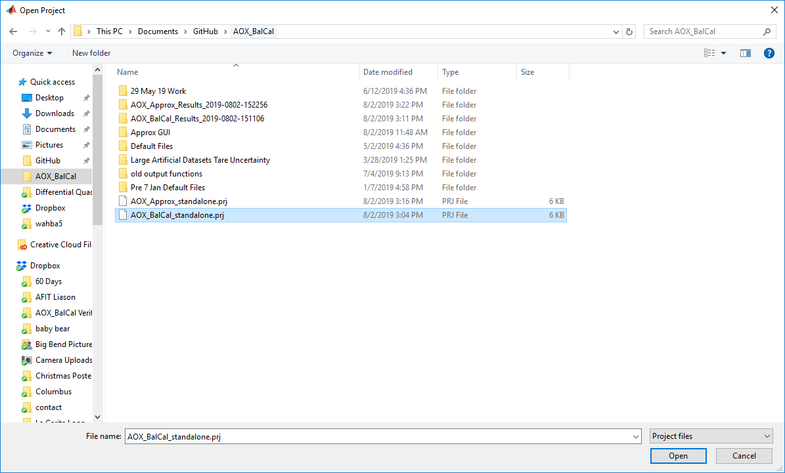

Open the project file (uploaded on Github) for either AOX_BalCal or AOX_Approx (instructions are the same for both)

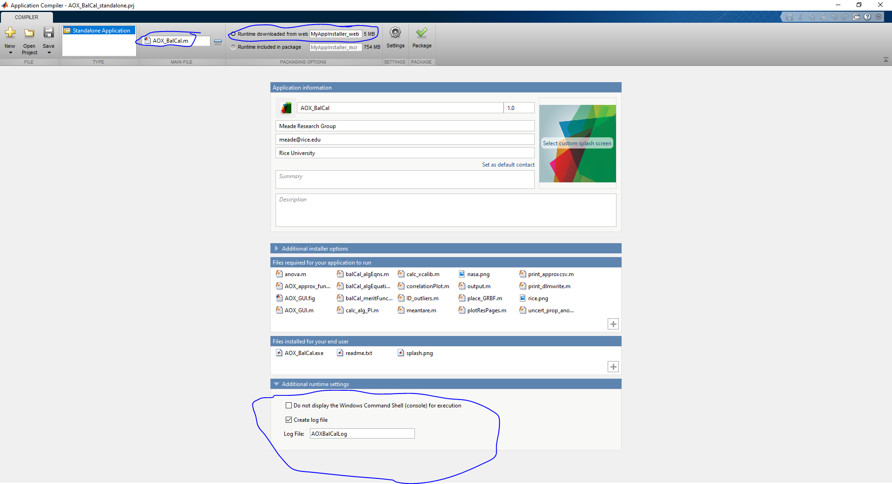

Ensure the above options are selected

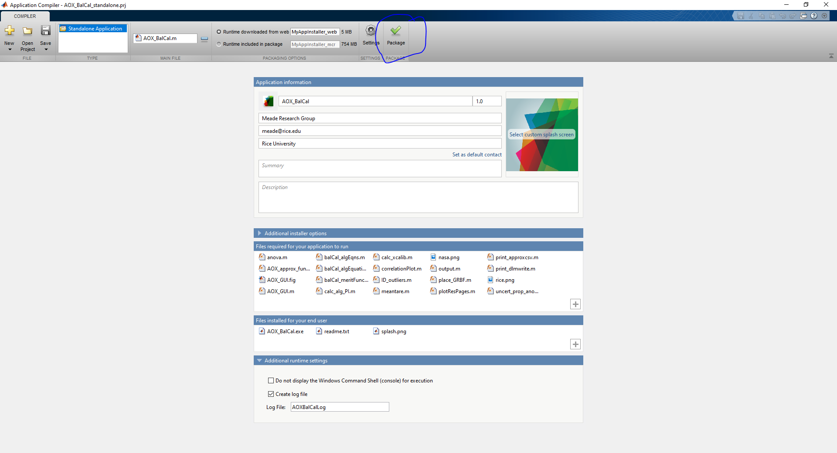

Select ‘Package’

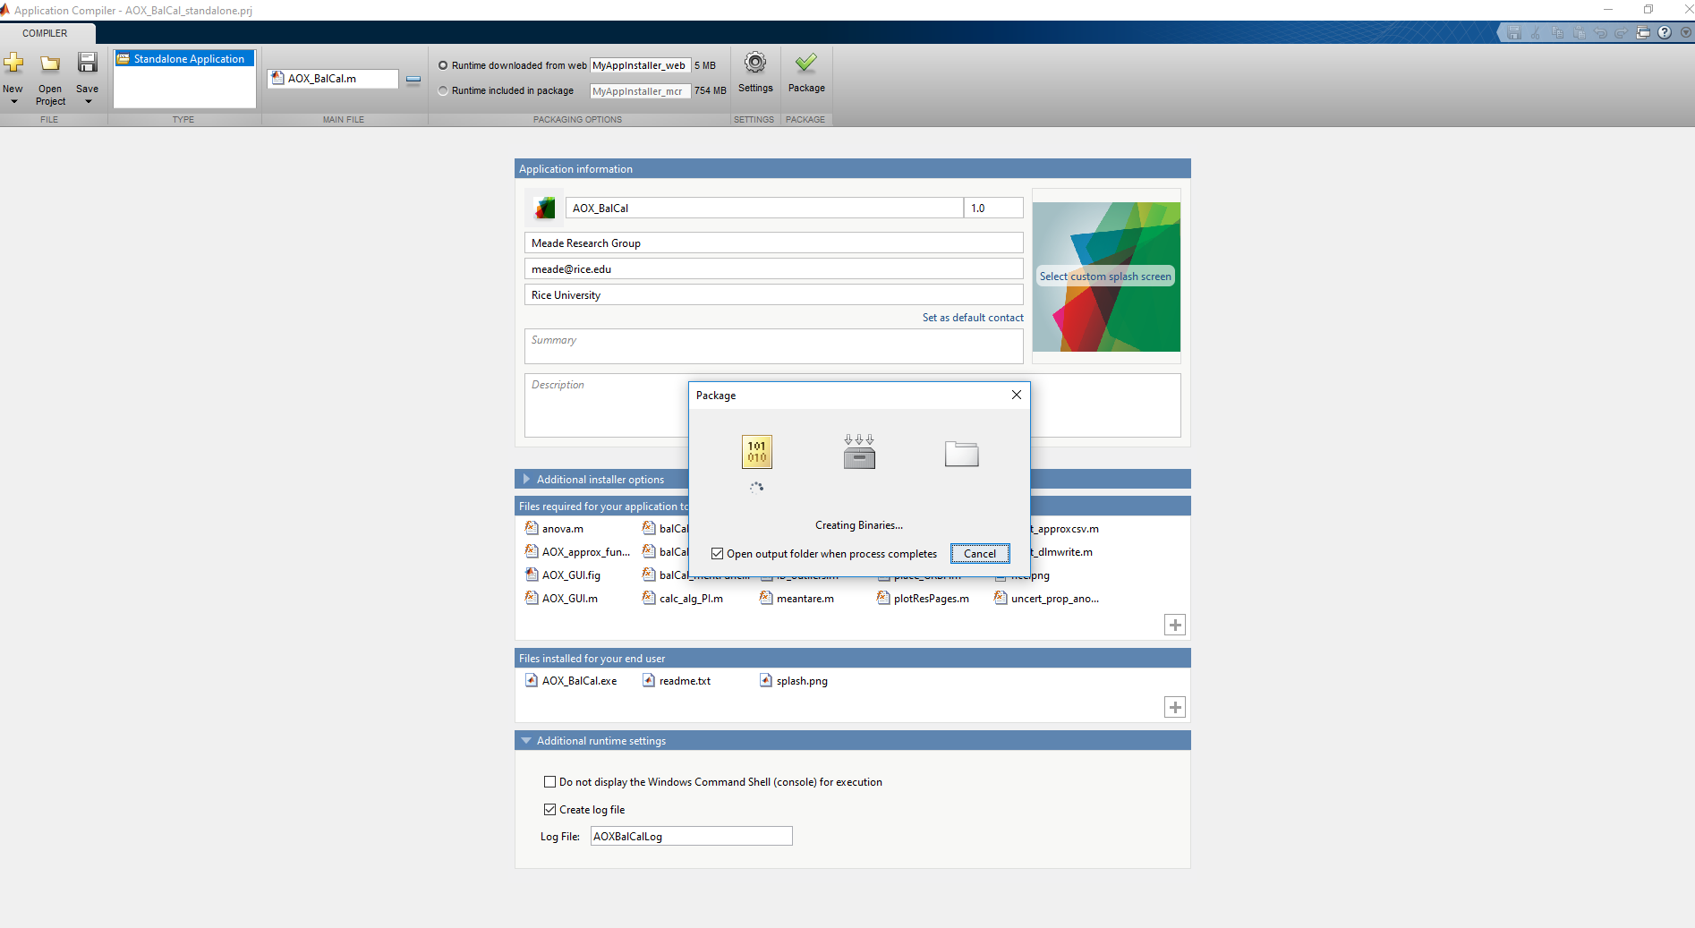

Wait for application to compile

**Installing Standalone Application**

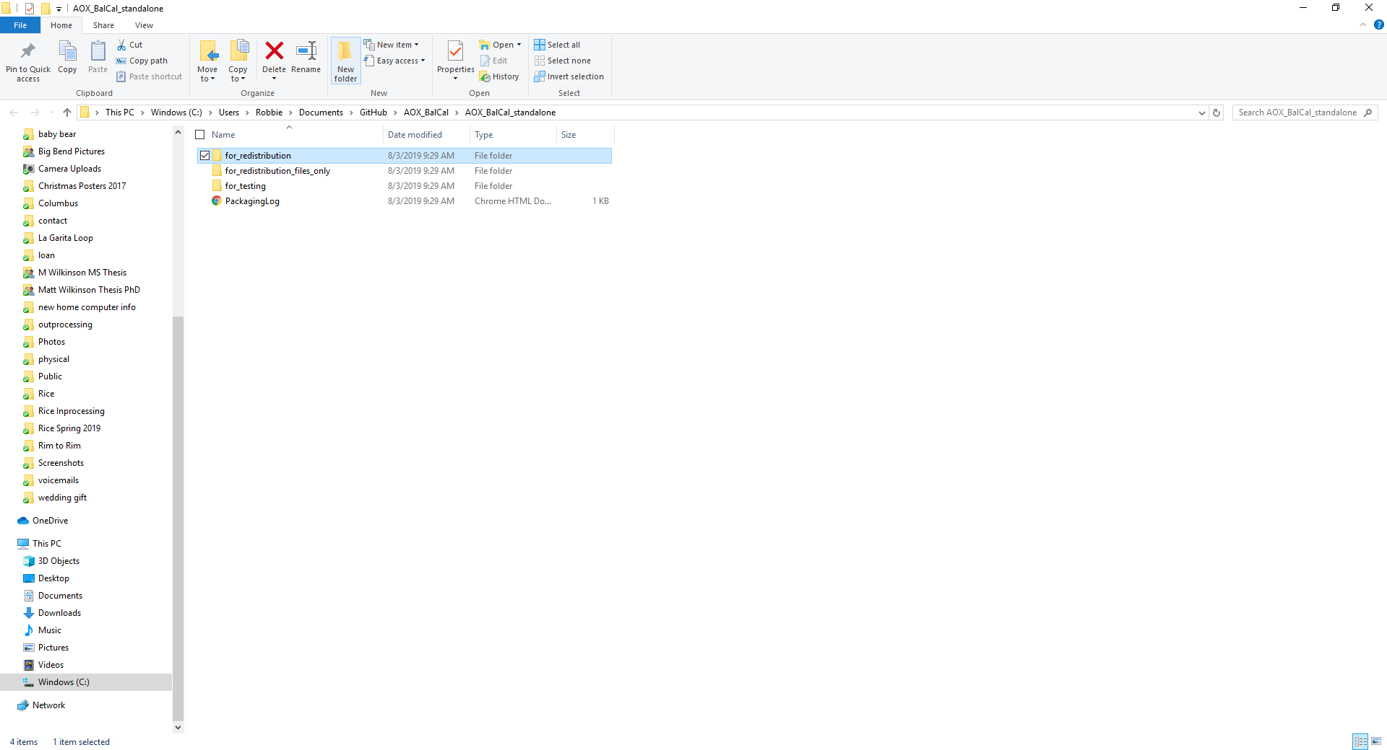

Once completed, open ‘for_redistribution’ in the created project folder

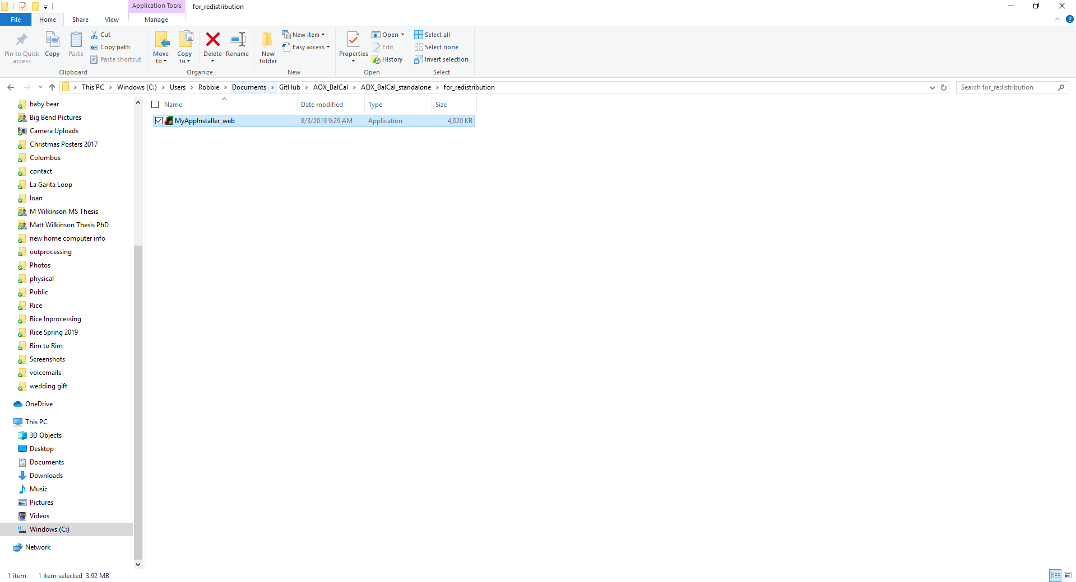

Run ‘MyAppInstaller_web’

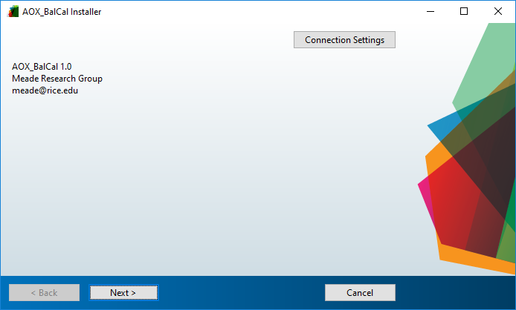

The installer will launch to guide you through the installation

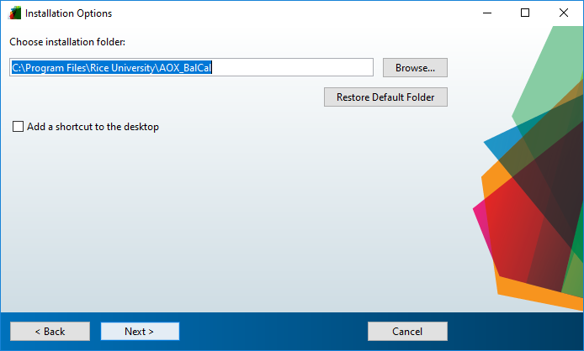

Selected desired installation location

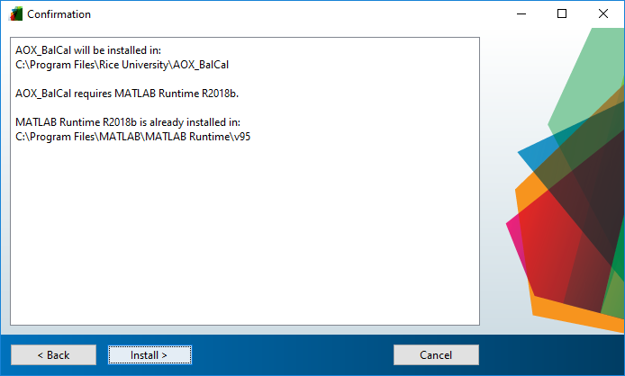

MATLAB Runtime must be installed if not already on computer. This is a free download that the installer will retrieve. It only needs to be installed once

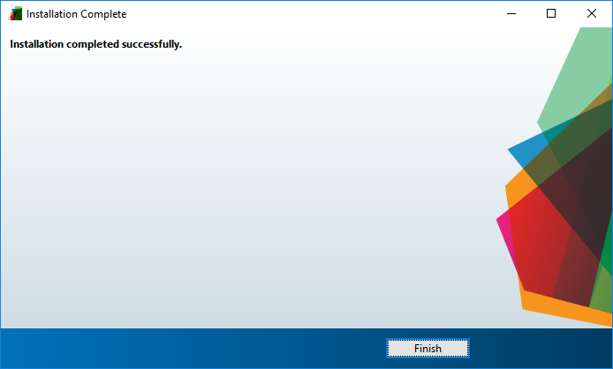

Wait for program to install, then select ‘Finish’

Run ‘AOX_BalCal’ or ‘AOX_Approx’ as you would any other program. Both will open a command line window before the GUI. It may take a few moments for the GUI to appear.

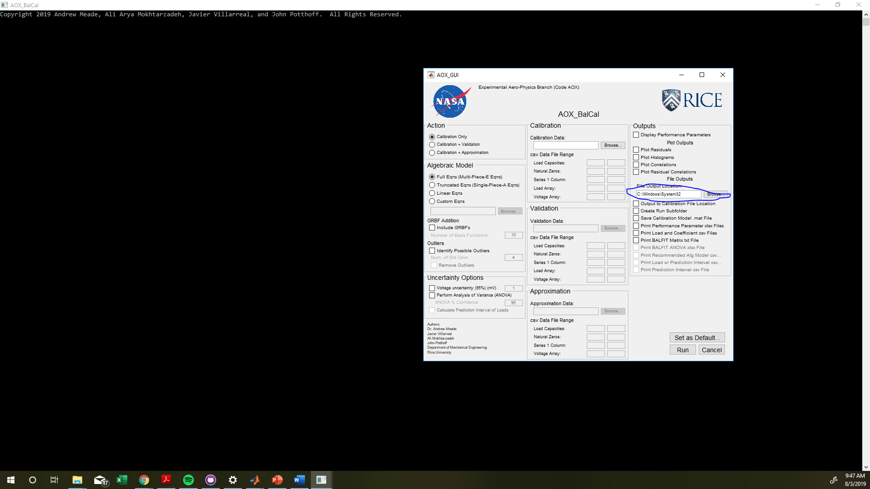

Select Desired options for calibration/approximation. Make sure to select the desired file output location. The program will most likely not be able to save files to the default location upon launch

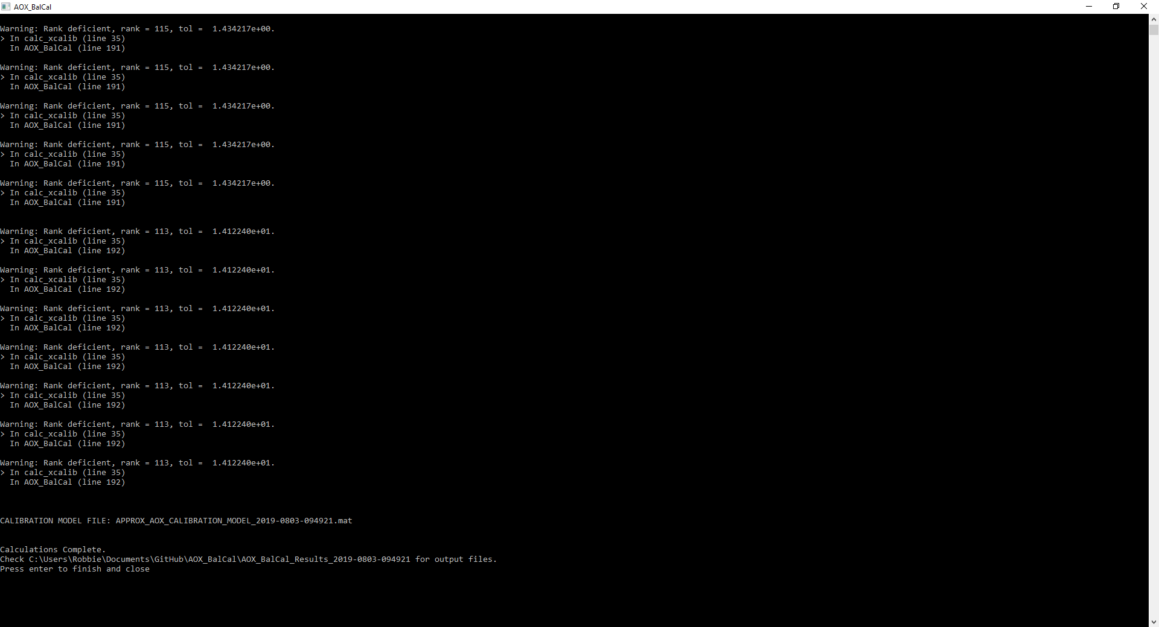

Select ‘Run’. The GUI will close but Command Window will remain open until the user presses ‘ENTER’